FRONT-END WEB DEVELOPMENT
Bean Boutique Coffee Shop
Name: Htut Khant Nyar
School Name: WEBS Education
Batch Name: Batch 6
Submission Date: 21.10.2026
Word Count – Task 3: [Add your information here]
Word Count – Task 4: [Add your information here]
Total Word Count: [Add your information here]

Table of Contents
1. Introduction
2. Task 3 – Website Testing and Test Report
2.1 HTML and CSS Validation
2.2 Accessibility Testing
2.3 Browser Testing
2.4 Testing Problems and Corrections
2.5 Testing Evaluation and Role of W3C
3. Task 4 – Critical Evaluation
3.1 Front-end and Back-end Technology
3.2 Evaluation of Three Plugins
3.3 Version Control and GitHub
3.4 Front-end Framework and Bootstrap
3.5 USP and Future Improvements
4. Conclusion
5. References

1. Introduction

I was tasked with developing a website for Bean Boutique Coffee Shop. Until recently, Bean Boutique has been a local business within its community. However, now they are looking to expand their business ventures into the web space. I have created this website, which will allow customers to order through an online medium right from the comfort of their own home, and allow the establishment to promote their brand and showcase their services and products with an aesthetically pleasing digital site.
Tasks 3 and 4 contain detailed results of the testing, analysis, and recommendations for further improvements.

2. Task 3 – Website Testing and Test Report

2.1 HTML and CSS Validation
In this project, I used the W3C Markup Validation Service to validate HTML and the W3C CSS Validation Service to check CSS (World Wide Web Consortium (W3C), 2025). During the development and testing of the webpage, I encountered several problems with the hierarchy of headings and the styling of the Squricle elements. Some headings were not arranged in the correct order sequence, while the Squricle elements required adjustments to achieve the rounded-corner appearance and to vary their shape and sizes. I resolved the heading issues by reviewing the HTML structure and rearranging the headers in the proper order by hierarchy. For the Squricle elements, I modified the CSS properties, including border-radius and other styling rules, to ensure the elements displayed correctly and consistently across the webpage.

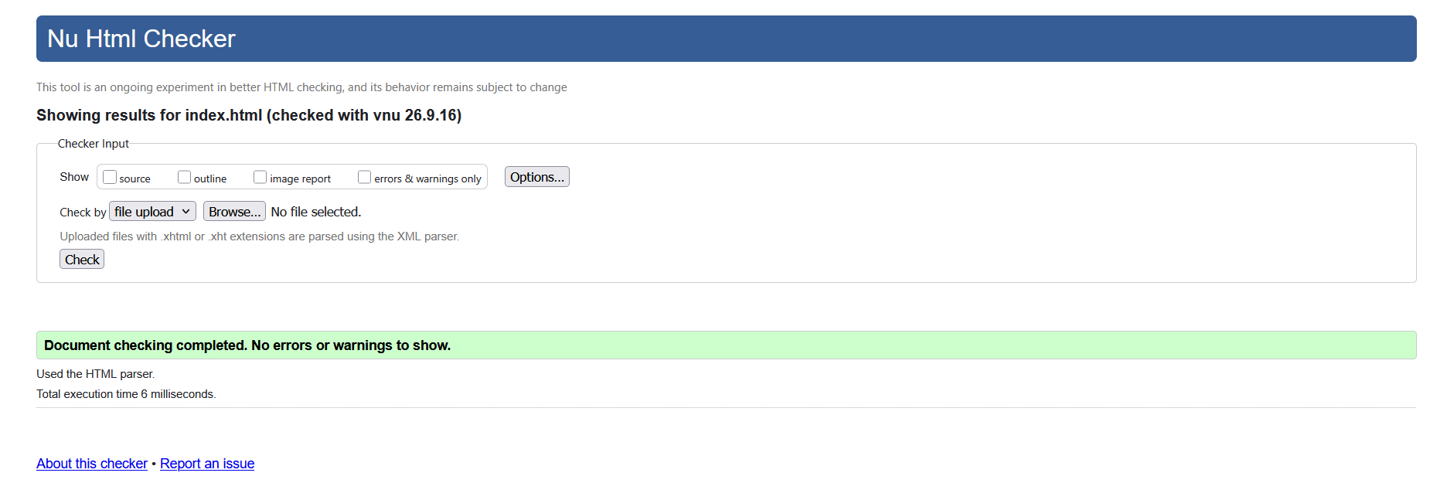
Figure 1: Validation of Home Page

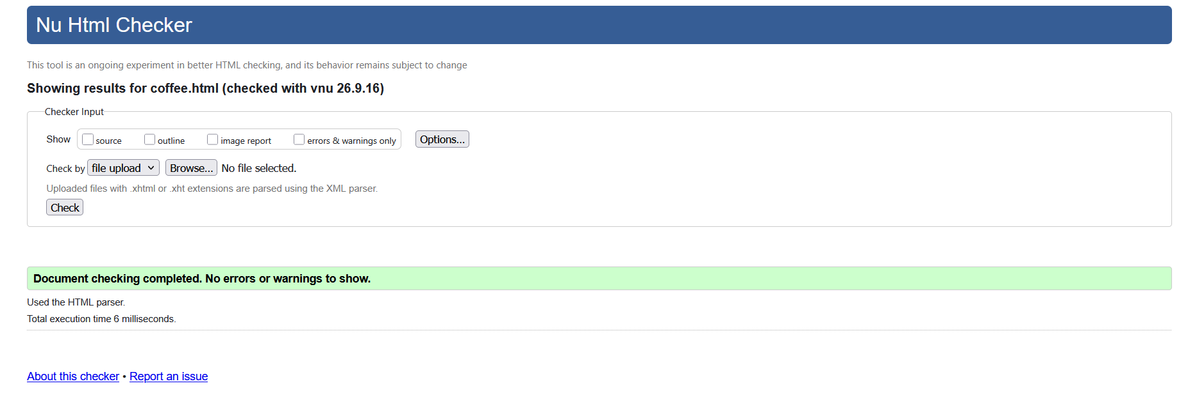
Figure 2: Validation of Product Page

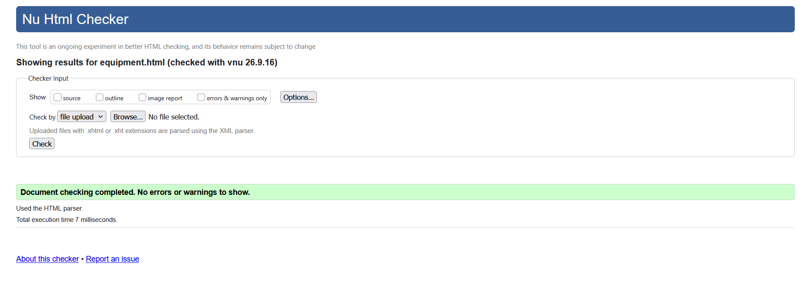
Figure 3: Validation of Equipment Page

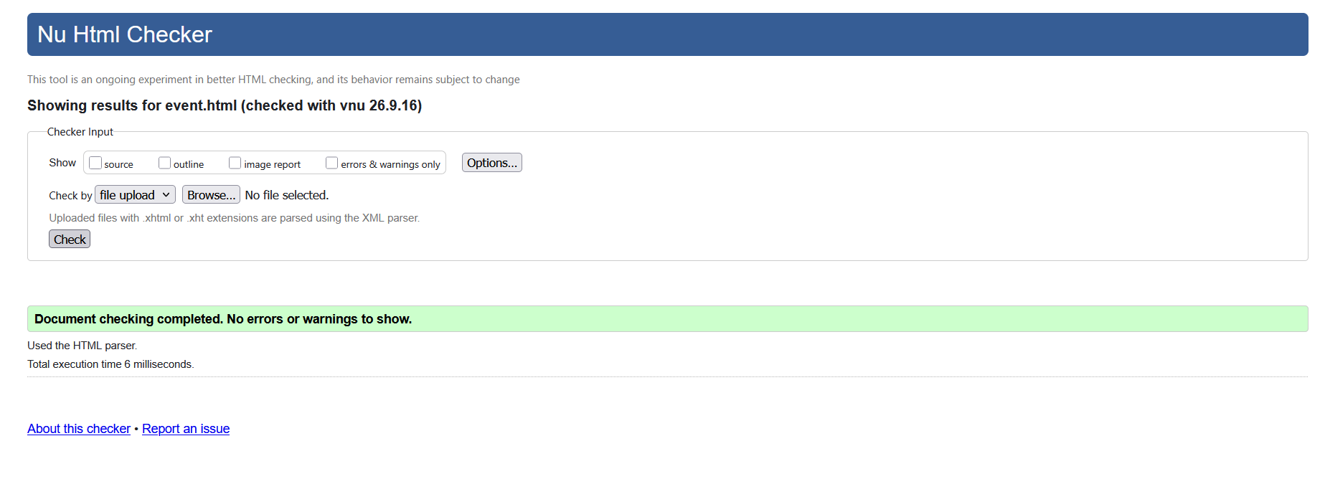
Figure 4: Validation of Event Page
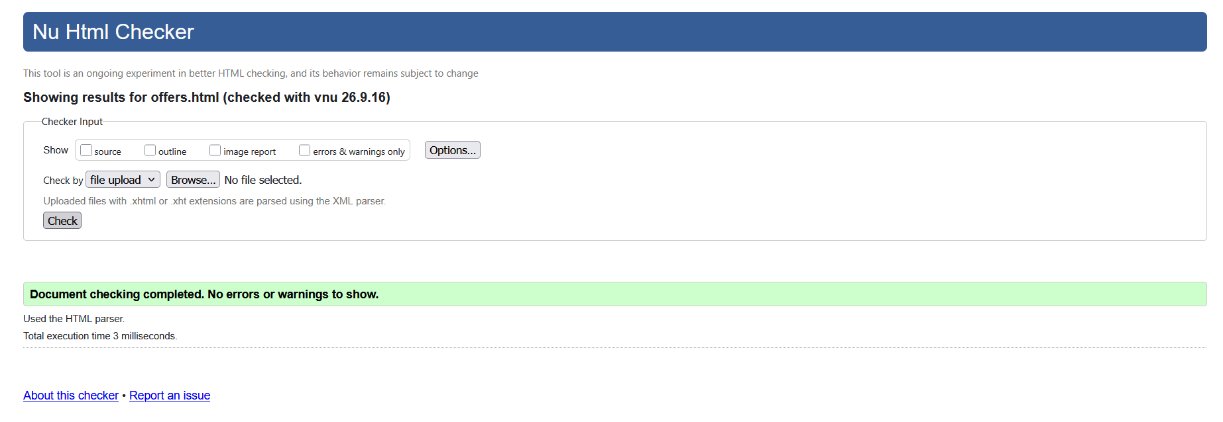
Figure 5: Validation of Offer Page

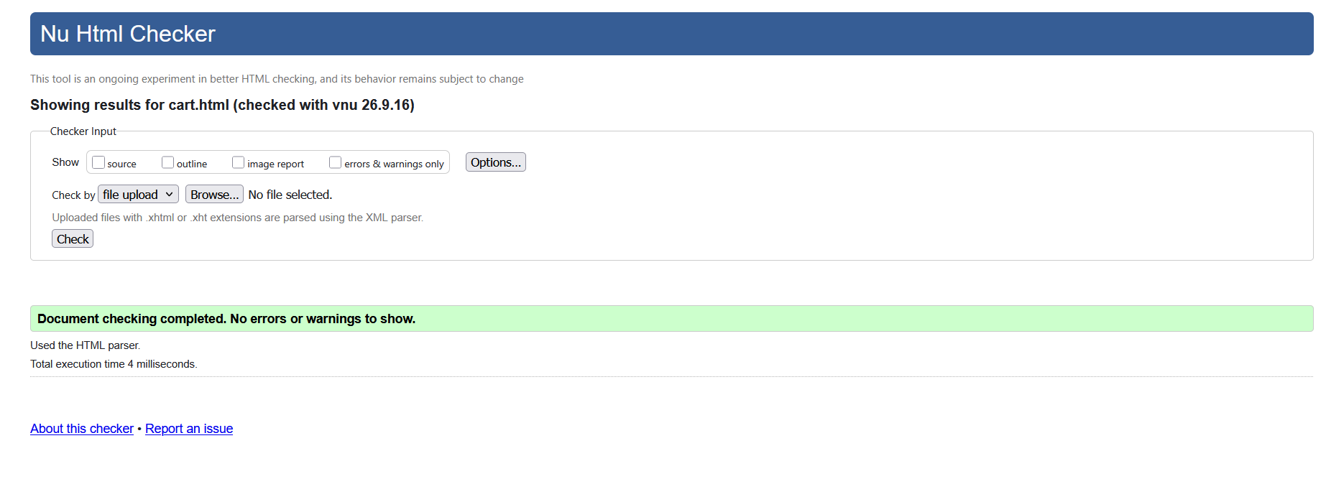
Figure 6: Validation of Cart Page
Similarly, I also validated my style.css file utilizing the W3C CSS Validator. First time testing revealed errors with the root color scheme and it’s interaction with the transparent liquid-glass style elements. I managed to fix the issue and the final test showed “No errors found.”
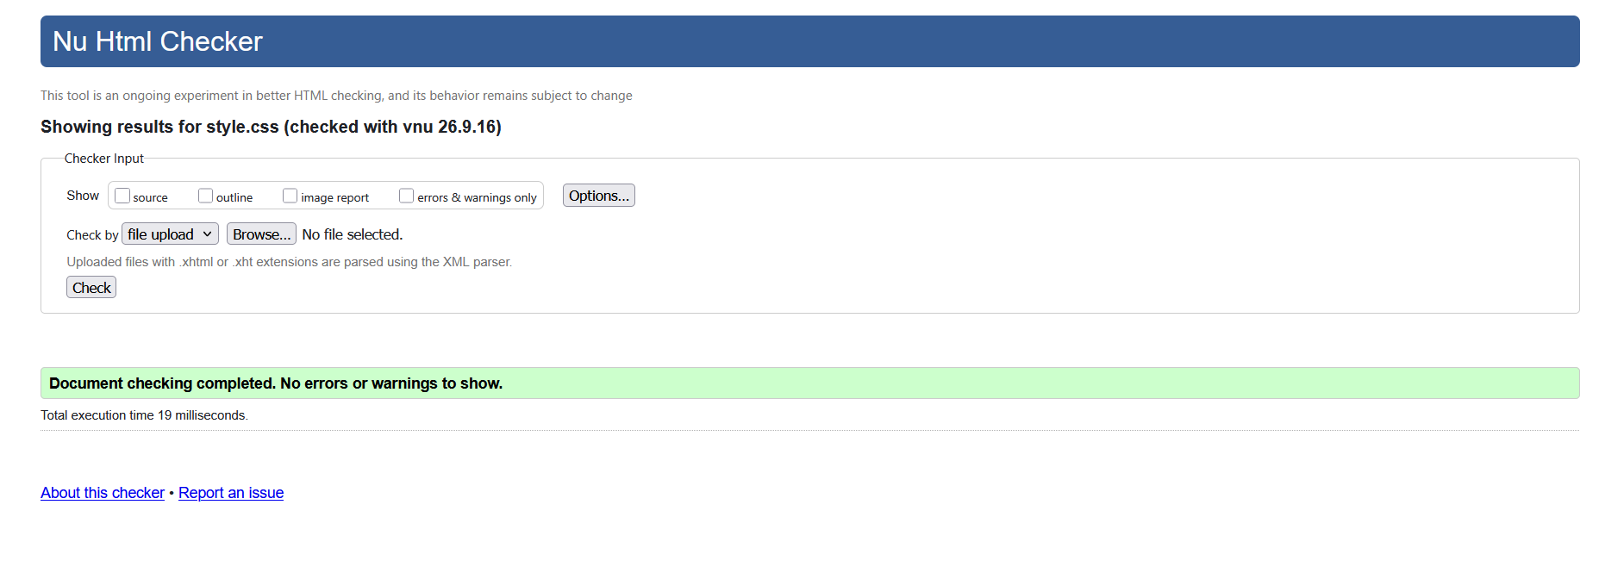
Figure 7: Validation of CSS Page

2.2 Accessibility Testing
Additionally, I tested the website’s accessibility using the NVDA screen reader app (NV Access, 2025). NVDA is used for people with disabilities to navigate the web and use websites easier with features such as high contrast modes, keyboard navigation, and screen reader. I then tested and verified that the website is NVDA compatible.
All images had alt tags, and links contained detailed text labels. The screen reader correctly read the headings and contents in chronological order. The screen reader test confirmed that my HTML building was accessibility positive.
Still, I found that a few things needed improvements. For example, some texts could have stronger contrasts for good visibility. In future assessments, I plan to add better contrasts to further enhance vison accessibility.
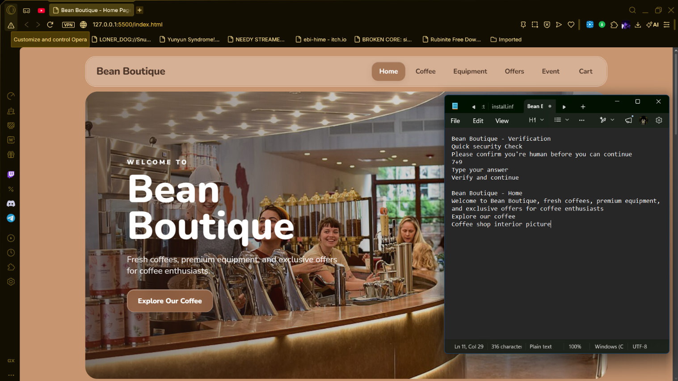
Figure 8: Accessibility Evaluation Report From NVDA

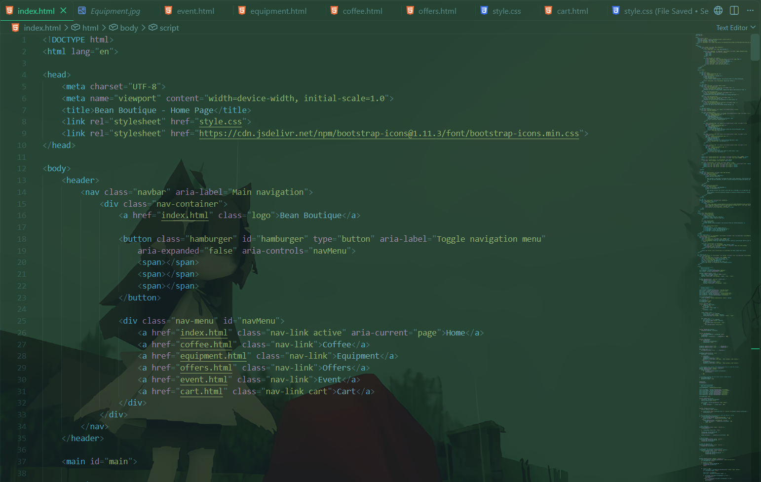
Figure 9: Example of ARIA Label Implementation in Navigation Bar

2.3 Cross-Browser Testing
I tested my website on two different browsers: Opera GX and Google Chrome. The primary purpose was to make sure the website works the same on multiple browsers and in multiple orientation and screen sizes. I tested all the pages on both desktop view and mobile view if the designs adjusted to different screen sizes. The results of the cross-browser multi-device testings are given below in detail for the systematic analysis.
Table 1. Browser Testing Results
Feature tested | Desktop browser  (Opera GX) | Mobile browser  (Google Chrome) | Notes / result
Navigation | Pass | Pass | Both browsers showed the same layouts.
Images | Pass | Pass | No image errors.
Search | Pass | Pass | Search function works.
Forms | Pass | Pass | Registration works but there’s no backend storage for the details.
Shopping cart | Pass | Pass | Cart function works but there is no way to add payment.
Responsive layout | Pass | Pass | It was responsive on both devices and browsers.

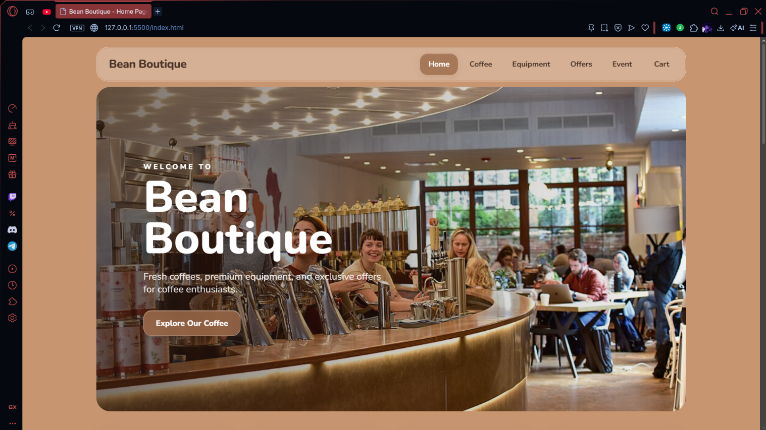
Figure 10: Homepage Display in Opera GX
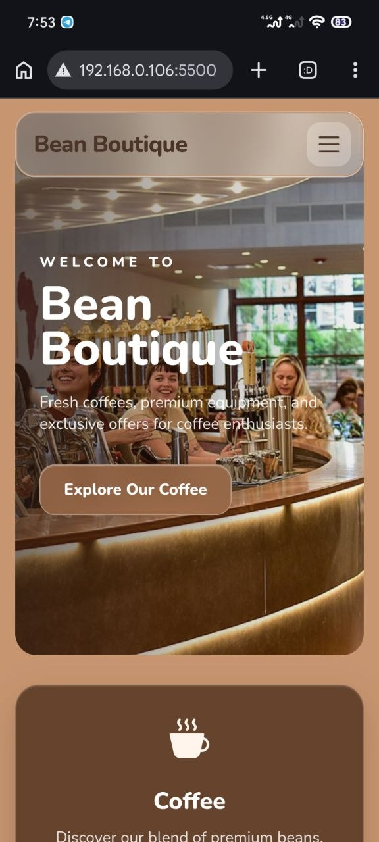
Figure 11: Homepage Display in Chrome (Mobile)

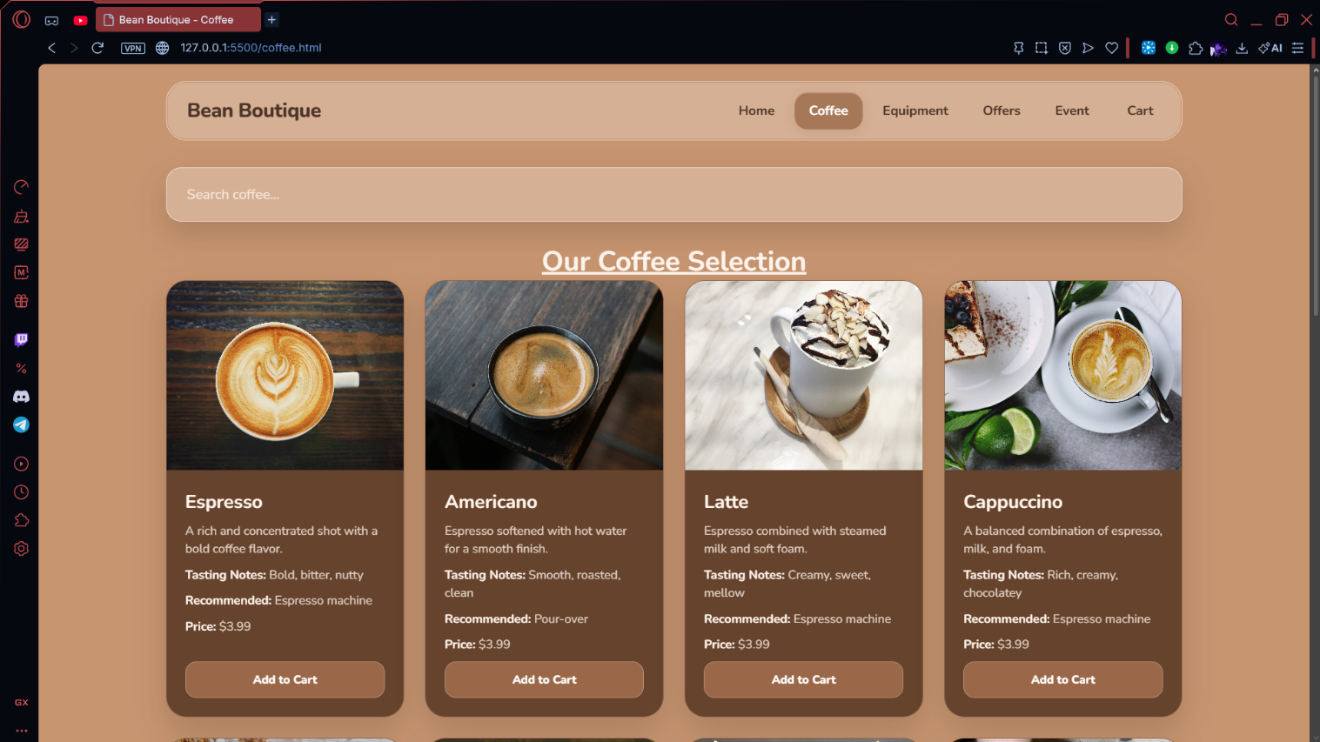
Figure 12: Coffee Page Display in Opera GX
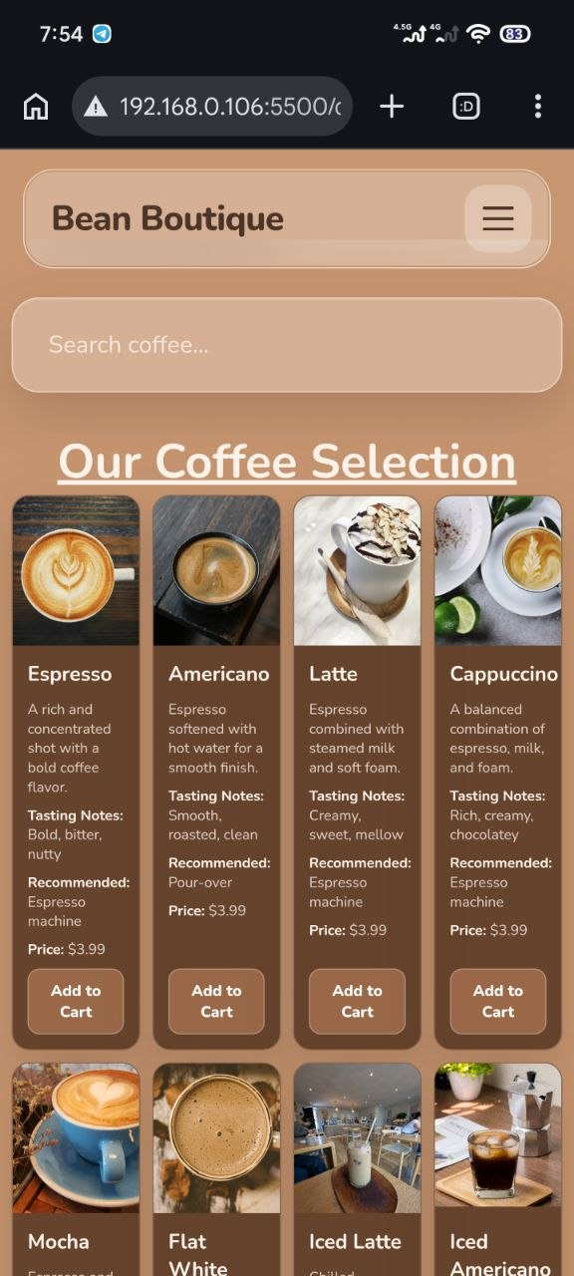
Figure 13: Coffee Page Display in Chrome (Mobile)
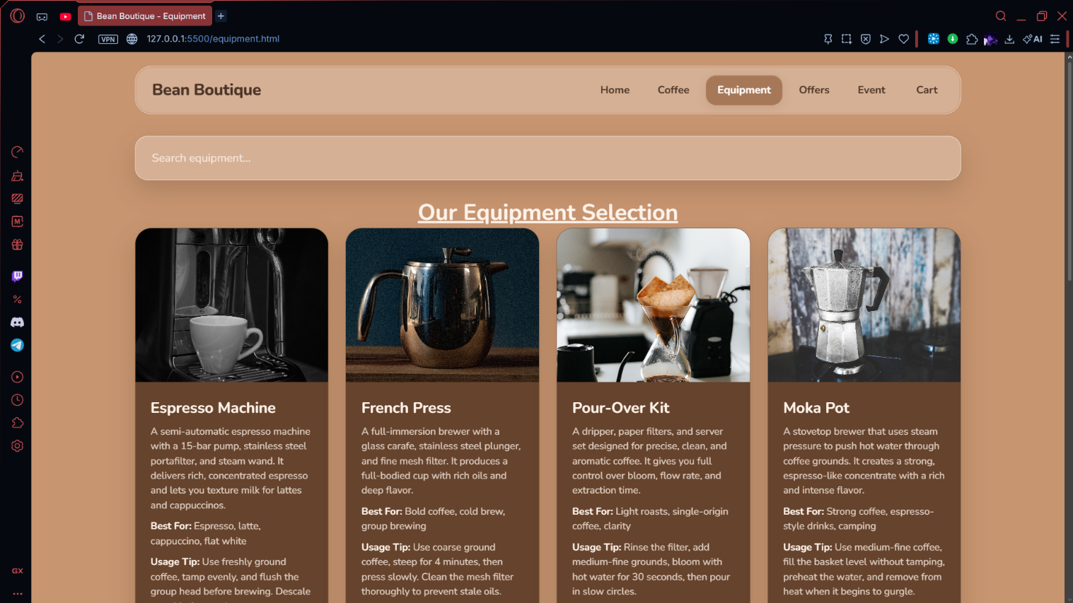
Figure 14: Equipment Page Display in Opera GX
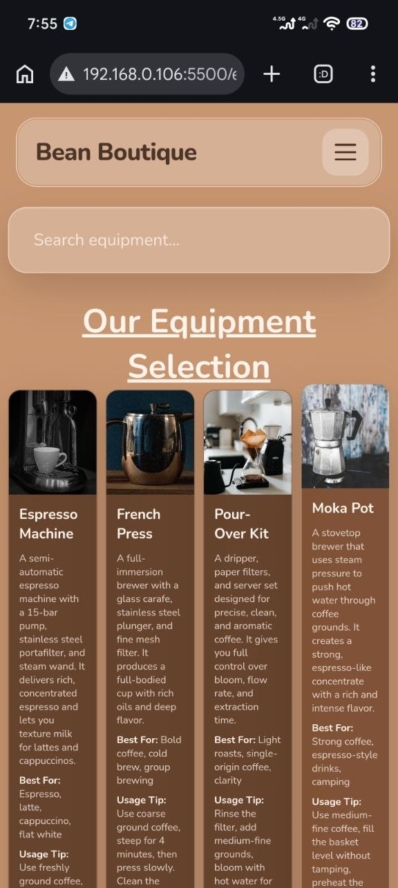
Figure 15: Equipment Page Display in Chrome (Mobile)
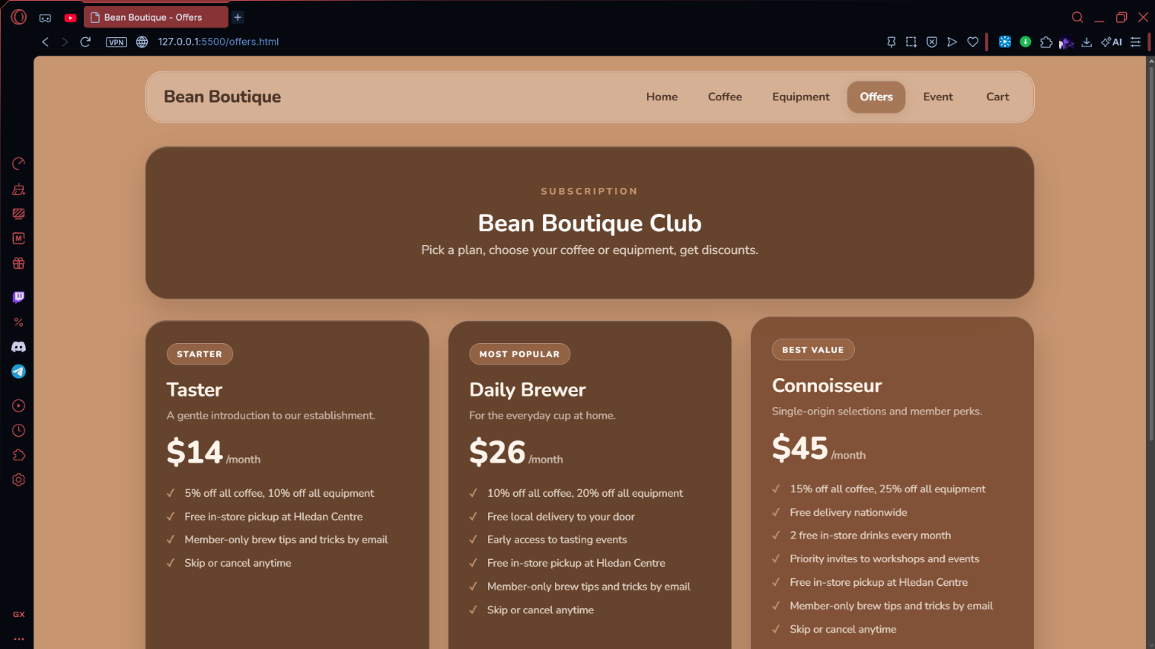
Figure 16: Offers Page Display in Opera GX
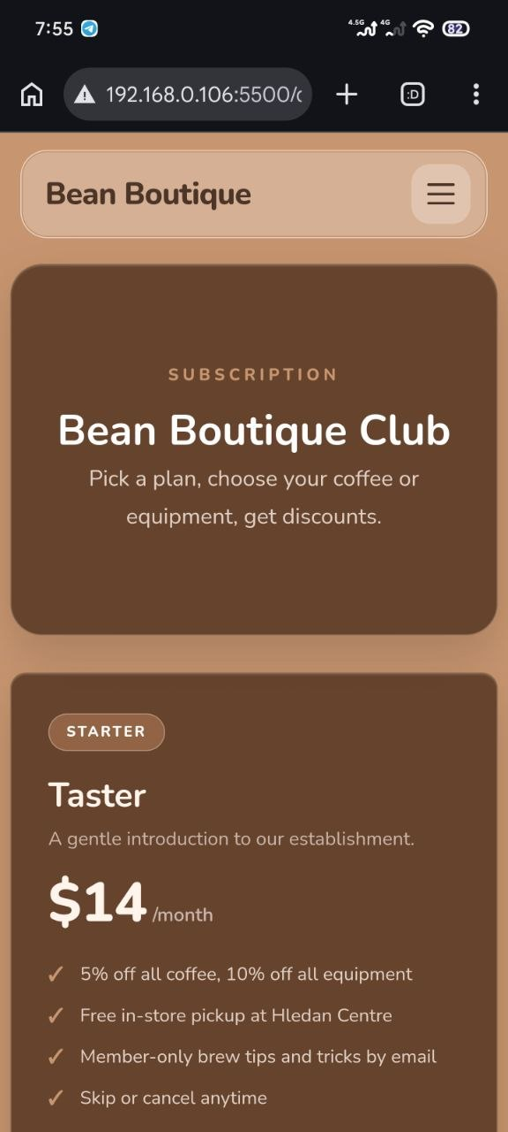
Figure 17: Offers Page Display in Chrome (Mobile)
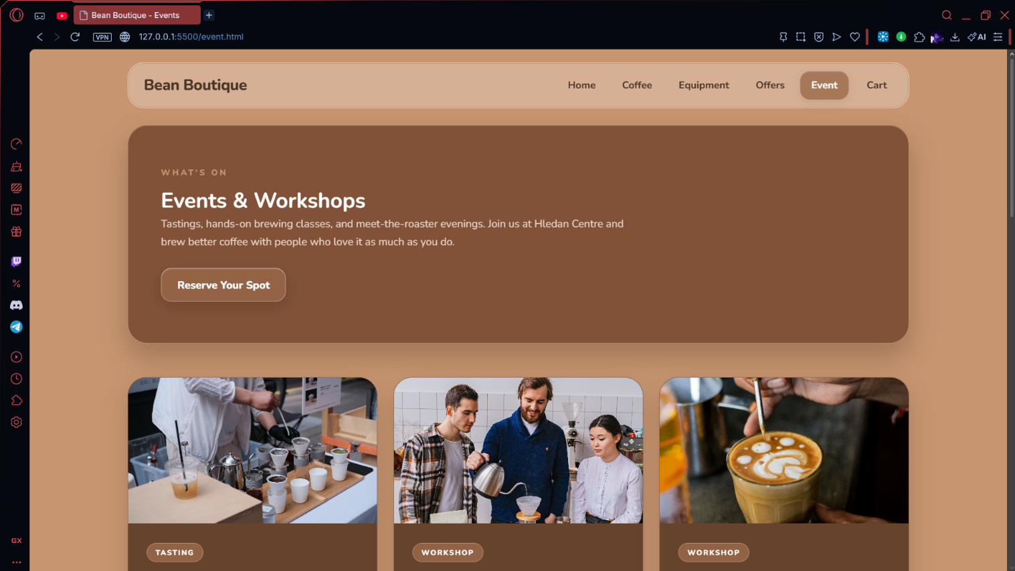
Figure 18: Event Page Display in Opera GX
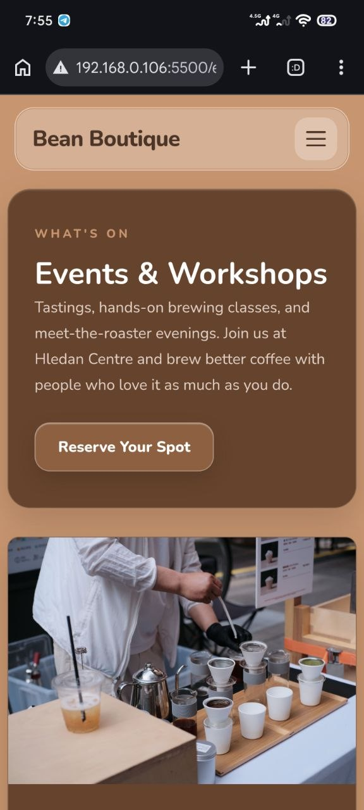
Figure 19: Event Page Display in Chrome (Mobile)
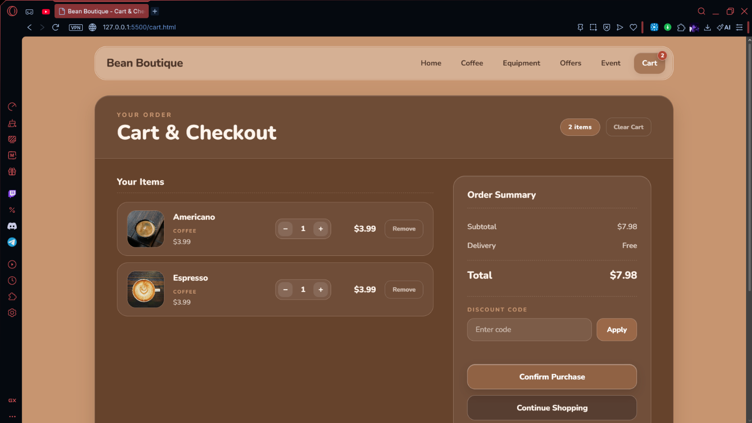
Figure 20: Cart Page Display in Opera GX
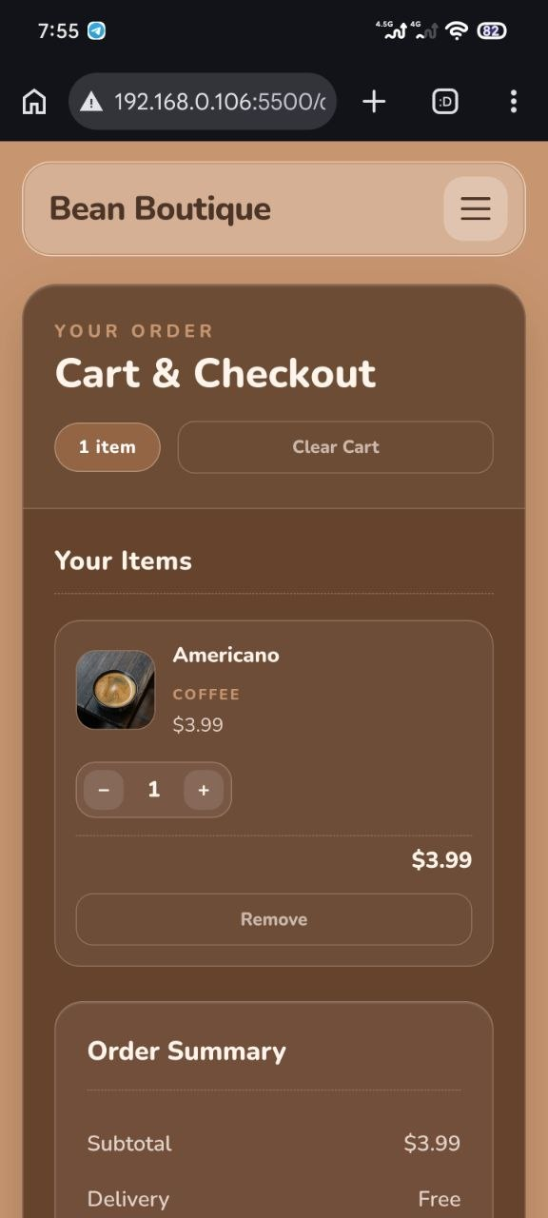
Figure 21: Cart Page Display in Chrome

2.4 Testing Evaluation and Role of W3C
By using these methods for validation and testing for my website, I confirmed my website worked properly and user-friendly.W3C Validator verified my HTML and CSS code had no errors, good accessibility for disabled individuals, and design consistency across multiple browsers and multiple devices.
Furthermore, these testing techniques were effective in identifying and correcting errors. The World Wide Web Consortium (W3C) establishes international standards for HTML and CSS, and following these guidelines helped improve the website's overall quality and user experience. These evaluations also strengthened my understanding of professional web development practices, emphasizing the importance of maintaining consistency, accessibility, and user-centered design. Regular testing helps ensure website stability and supports long-term compatibility with evolving technologies (W3Schools, 2024).

3. Task 4 – Critical Evaluation

3.1 Front-end and Back-end Technology
The front-end system refers to the client-side component of a web application, designed to present information to users and capture their interaction through the browser. For the Bean Boutique website, it is built with three core technologies. HTML defines the structure of each page, including the home, coffee, equipment, offers, event, and cart pages, using semantic elements such as header, nav, main, section, and footer. CSS, contained in a shared stylesheet, controls the visual presentation, including color, texts, card layouts, and the hero banner. JavaScript adds interactivity, such as the mobile navigation menu, the featured carousel, the first-time visitor pop-up, the CAPTCHA check, and the shopping cart, which calculates totals and applies discount codes. Together, these elements form the user interface, which consists of the menus, buttons, forms, and modal windows that customers interact with. Responsive design is also applied through a viewport meta tag and CSS media queries, allowing the layout to adapt to desktop, tablet, and mobile screens, where the navigation collapses into a hamburger menu.
The back-end system refers to the server-side component of a web application, designed to manage logic, data storage, and client-server communication. For the Bean Boutique website, technologies such as PHP or Node.js can be used to handle dynamic content and database connectivity. PHP offers a mature scripting language with wide compatibility and strong integration with web servers, while Node.js provides an event-driven, non-blocking structure that efficiently manages multiple user requests. Additionally, a database such as MySQL can store products, events, customer accounts, and orders in a consistent and scalable way. These technologies would support key features of an online shop, including user registration and login, event registration, order processing, and secure payments through a trusted payment gateway. Security is a major responsibility of this layer. Passwords should be hashed, data should be transferred over HTTPS, and user input should be validated to prevent attacks such as SQL injection and cross-site scripting (Sharma, et al., 2024).
The main difference between the two lies in where the code runs and what it is responsible for. The front end runs in the user’s browser and focuses on layout, styling, and responsiveness, whereas the back end runs on a server and focuses on processing user input, storing it securely, and returning results to the front end through HTTP requests and RESTful APIs (Sharma, et al., 2024).

3.2 Evaluation of Plugins
I used multiple plugins but the most notable ones are the plugins that enhance the interactivity for site visitors and functionality of the Bean Boutique website.
Firstly, I made the Registration Form plugin that enables customers to register for events and provide contact information through the website. This plugin supports customer engagement through an online medium. Currently, the website only stores information using localStorage and it requires a proper back-end setup to ensure user information is stored securely.
Secondly, I used the Google Maps plugin provides an interactive view of the Bean Boutique’s location that makes it simpler for customers to find the shop. This plugin is helpful for first time visitors that don’t have to deal with the hassle of dealing with customer support and asking for directions for the store. Although there might still be loading delays by using and being dependent on Google’s external API.
Thirdly, I added the First Time Visitor Discount Popup plugin for newcomers to give them an incentive with a promotional offer. By entering their email, they can claim a discount up to 10% off on any product they purchase. This plugin promotes an increase in sales and enhances the online shopping experience.
Lastly, I added an extra plugin which is a CAPTCHA plugin. A popup will appear asking the visitor to complete a simple arithmetic problem and after solving the CAPTCHA, they can now access the website. This plugin is useful to combat bots and improve security. In the future I plan to replace it with the Google reCAPTCHA plugin to make it even simpler for visitors and those who might not be good with math.

3.3 Version Control and GitHub
A Version Control System (VCS) is a program that designed to track and manage changes within the source code of a project. It systematically records modifications within the codebase and preserves a structured history of the project’s evolution. Among these systems, Git is the most widely used Distributed Version Control System, whereas GitHub functions as a cloud-based service for managing and sharing repositories. (GitHub, 2024).
Integrating GitHub into the Bean Boutique project improves version control, data backup, and access to project files across different devices. Rather than making changes to files manually without a record, developers can upload updates, examine previous commits, and restore earlier versions when errors occur. This helps maintain the reliability of project files while keeping development activities organized.
Furthermore, GitHub provides a centralized platform for storing and managing the Bean Boutique project. Features such as README files and issue tracking help document the development process, record problems, and monitor improvements. These tools contribute to a more structured workflow and make it easier to maintain and develop the website over time.

3.4 Front-end Framework and Bootstrap
A frontend framework is a set of tools and pre-written code that helps developers create websites and web applications more efficiently. Frameworks like Bootstrap simplify the design process by offering reusable components, such as navigation bars, buttons, and responsive page layouts.
Using Bootstrap makes developing the Bean Boutique website more efficient because it provides ready-to-use components and a responsive grid system.
These features allow the website's layout to adapt automatically to different screen sizes, ensuring a suitable display on both desktop computers and mobile devices (Bootstrap, 2024).
Bootstrap supports the development of responsive and consistent websites through its predefined components and flexible layout system.
For the Bean Boutique project, it provides a practical frontend structure that simplifies the design process and helps maintain a consistent appearance across different devices.

3.5 USP and Future Improvements
What to include
Explain your website’s unique selling point (USP), which technology adds the most value, and recommended future improvements. Only mention features that actually exist.
[Add your text / evidence here]

4. Conclusion
Write here
Briefly summarise testing results, the overall website, and future development.
[Add your text / evidence here]

5. References
References list
Add all sources you used, formatted consistently. Include URLs and access dates where required.
[Add your text / evidence here]

